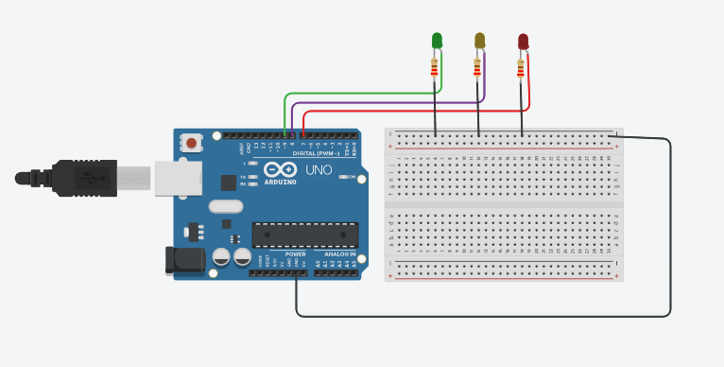

#define GREEN_LED 9

#define YELLOW_LED 8

#define RED_LED 7

char userInput;

void setup() { Serial.begin(9600);

pinMode(9, OUTPUT);

pinMode(8, OUTPUT);

pinMode(7, OUTPUT);

digitalWrite(9, LOW);

digitalWrite(8, LOW);

digitalWrite(7, LOW);

Serial.println("Enter \ng for green LED,\ny for yellow LED,\nor r for red led:");

}

void loop() {

if (Serial.available() > 0) { userInput = Serial.read();

digitalWrite(9, LOW);

digitalWrite(8, LOW);

digitalWrite(7, LOW);

switch (userInput) {

case 'B': // Blink the Green LED

for (int i = 0; i < 5; i++) { // Blink 5 times digitalWrite(9, HIGH); delay(300);

digitalWrite(9, LOW); delay(300);

}

break;

case 'g':

digitalWrite(9, HIGH); break;

case 'y':

digitalWrite(8, HIGH); break;

case 'r':

digitalWrite(7, HIGH); break;

default:

Serial.println("Invalid input. \nEnter \ng for green LED,\ny for yellow LED,\nor r for red led:"); break;

}

}

}